Cryptography
One-Time Pad: Two-Pad Attack
- Reuse of same key stream leaks relation between plaintexts:
C1 = P1 ⊕ K, C2 = P2 ⊕ K ⇒ C1 ⊕ C2 = P1 ⊕ P2
- If one plaintext is known or guessable, the other can be recovered.
- Equal plaintexts produce equal ciphertexts (pattern leak).
- Rule: Never reuse key stream (also applies to stream ciphers).
Stream vs Block Ciphers
Stream Ciphers
- Generate pseudo-random key stream S = StreamCipher(IV,K).
- Encryption: C = P ⊕ S.
- Fast, bit/byte oriented, low latency.
- Fatal if nonce reused → same two-pad attack.
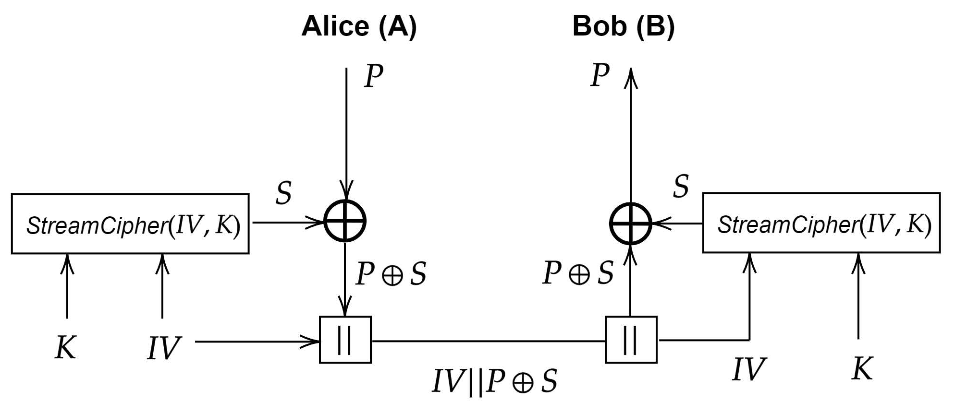
Block Ciphers
- Operate on fixed block size (AES: 128-bit).
- Modes of operation semantics: ECB – deterministic, pattern leaks, avoid. CBC – uses random IV, needs MAC for integrity. CTR – turns block cipher into stream, needs unique nonce. GCM – AEAD mode (confidentiality + integrity).
- Pros: hardware support, flexible AEAD modes.
- Cons: padding issues (CBC), IV misuse.
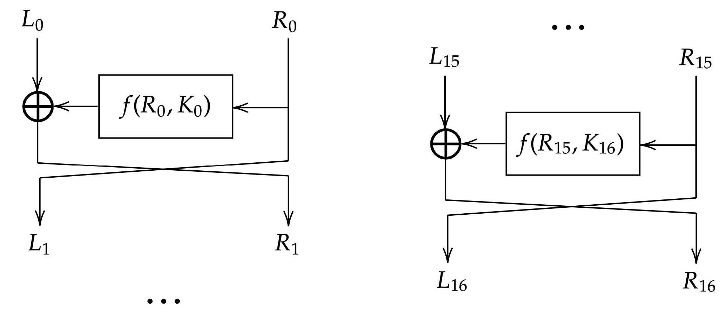
Theoretical Properties
Symmetric Encryption
- Provides confidentiality.
- Security defined by indistinguishability (IND-CPA / IND-CCA).
- Key space 2^k; brute force cost ≈ 2^(k-1).
Asymmetric (Public-Key)
- Uses key pair (pk, sk).
- Enables key exchange, encryption without pre-shared secret, and signatures.
- Slower; usually used only for key establishment.
Hash Functions
- Map variable input to fixed n-bit output.
- Properties: Preimage resistance – hard to find input for given hash. Second-preimage resistance – hard to find different input with same hash. Collision resistance – hard to find any two inputs with same hash (≈2^(n/2) effort).
- Used for: integrity, digital signatures, password hashing, HMAC, commitments.
Problem Solved by Asymmetric Cryptography
- Addresses the key distribution problem: allows secure communication without pre-shared secret.
- Anyone can encrypt using public key; only private key holder can decrypt.
- Enables digital signatures, hybrid encryption(Use PK share symmetric key).
Confidentiality, Integrity, Authentication
Confidentiality
- Only authorized parties can read the message.
- Achieved by encryption (e.g., AES, ChaCha20).
Integrity
- Message cannot be modified undetected.
- Achieved by MAC, HMAC, AEAD, or digital signatures.
Authentication
- Entity authentication: verify who is communicating (e.g., challenge-response).
- Message authentication: verify origin and integrity of message (MAC or signature).
Relationships
- Encryption alone → confidentiality only.
- Signature or MAC → integrity + authentication.
- AEAD (AES-GCM, ChaCha20-Poly1305) → confidentiality + integrity together.
- Signatures do not hide message content.
Digital Signatures
Security Properties
- Authenticity – verifies identity of signer (via certified public key).
- Integrity – any change in message breaks verification.
- Non-repudiation – signer cannot deny valid signature.
Structure
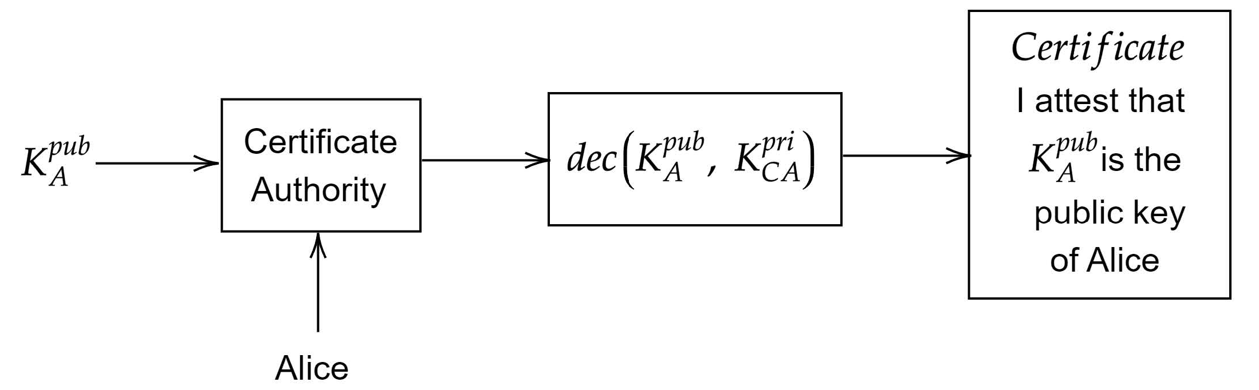
1. Alice gets identified by the CA
2. Alice’s public key K^{pub}_{A} gets signed by the (trustworthy) CA using the CA’s
private key K^{pri}_{CA}
3. The signed public key K^{pub}_{A} is linked to Alice and the CA provides a certificate
4. Anyone that wants to confirm the certificate can check the CA’s signature by encrypting the certificate using the CA’s public key K^{pub}_{CA}

Cryptographic Implementations:
Performance parameters for hardware design
- Area (silicon used), Throughput (data per time), Power (peak),
Energy (per task), Time-to-Market (design time), Latency (time per item)
Important parameters when implementing crypto in HW/SW
- From HW perspective: fast speed (sometimes), low latency, low area, low power, low energy.
- From SW perspective / benchmarking: know the platform (word size, available instructions), measure clock cycles, memory occupation, power, energy; aim for fair, reproducible results.
Public-Key Encryption / Decryption
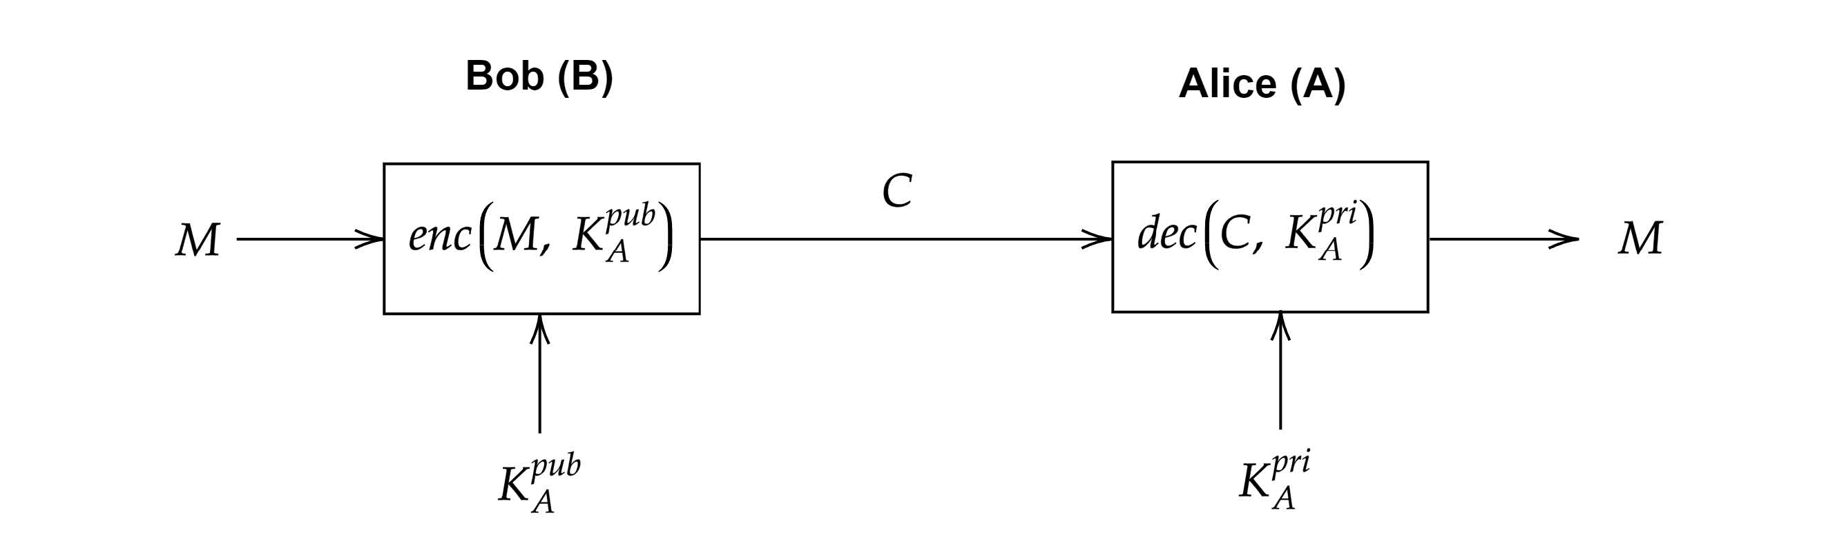
Software implementation: LUTs vs compute-on-the-fly
- LUT (tables): implement S-boxes and even whole round functions as look-ups → fewer instructions, higher speed; costs more memory. Best when code footprint and cache allow.
- Compute on the fly: cheaper in memory, portable across platforms; may increase cycles (consider shift/rotate costs on target CPU). Balance using platform knowledge (word size, instruction costs).
- Practical approach: profile on the target, report cycles and memory; pick the mix (partial tables + computed steps) that minimizes cycles under your memory budget.
Crypto algorithm selection nowadays (what guides the choice)
- Start from specifications: algorithm standard and system requirements drive the design flow.
- Then: Use standardized, publicly scrutinized algorithms (e.g., AES, RSA/ECC), then match to constraints (area, power, latency, throughput).
- Trend facts from slides: RSA (large keys) is slower; many systems moved to ECC; post-quantum migration is underway (lattice-based). Choose based on required security level and platform performance.

Cryptanalysis
What is a fault attack / DFA (high level)
- Attacker injects faults during computation (active attacker), obtains a fault-free ciphertext C and a faulted ciphertext C’ for the same plaintext P, and uses C ⊕ C’ (and how the fault propagates) to recover key material (divide-and-conquer on S-boxes / round parts).
Countermeasures (fault attacks)
- Redundancy / repetition: run operation twice and compare outputs (check mismatch → alarm).
- Error detection / correction for internal states.
- Sensors for voltage/clock/laser anomalies.
- Note: redundancy or comparisons themselves can be faulted (so use hardened checks / multi-layer defenses).
Timing attacks — idea & countermeasures
- Idea (simple): If execution time depends on secret data (branches, memory/cache behavior), attacker measures time (locally or remotely via RTT) and infers secret bits (e.g., PIN checking with early exit reveals prefix bits).
Practical countermeasures (timing)
- Constant-time implementations: remove data-dependent branches and memory access patterns.
- Avoid LUTs or ensure accesses do not depend on secret (compute S-box algebraically instead of table lookup; or use platform features).
- Hardware fixes: special hardware that enforces constant-time memory access (slower).
- Random delays: can increase noise but do not guarantee security (CLT reduces effectiveness with many samples).
Side channel attacks:
- AES rounds
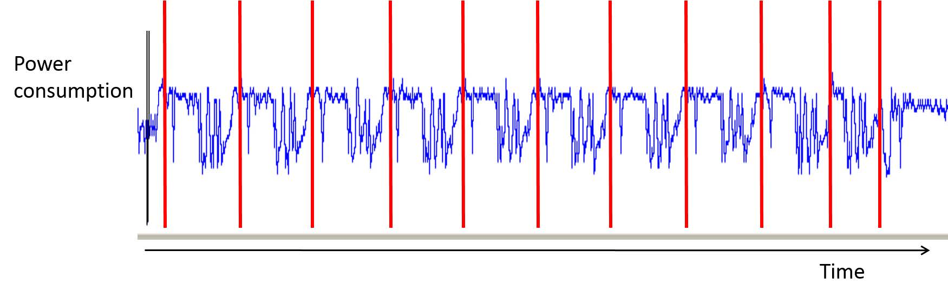
10 repeating patterns thus it’s AES-128, last round smaller due to the lack of MixColumns
- RSA square-and-multiply leak
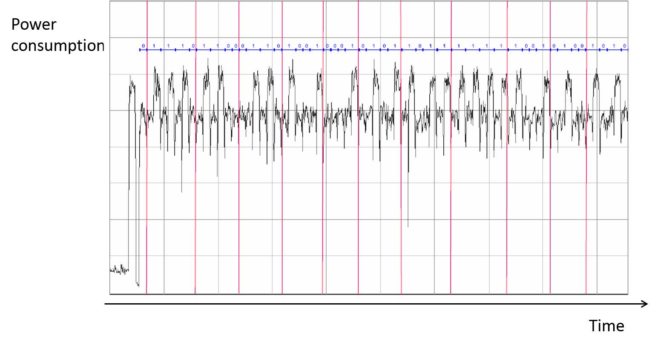
Modular exponentiation does square every loop and multiply only when exponent bit = 1. Presence/absence of the multiply shows up as longer execution and different power patterns(Timing+Power pattern attack.)
Correlation Power Analysis (CPA) Attack
Step 0: To perform CPA we must know the cipher’s structure
▶ All values (p, k, x, y) have size of 8 bits
▶ x = p ⊕ k
▶ y = S(x)
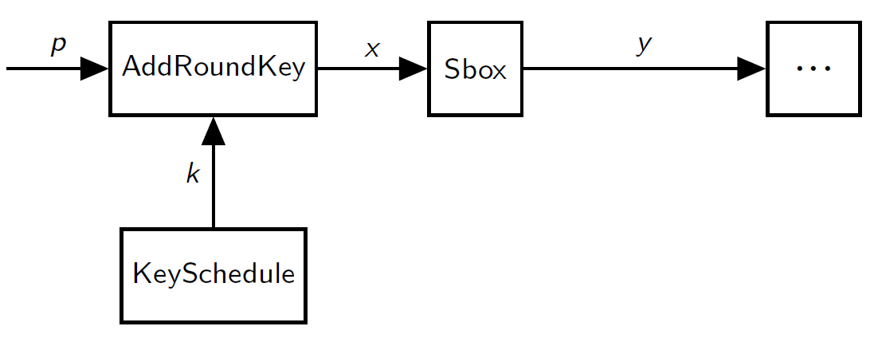
Step 1: Choose an intermediate value v of the cipher to attack
v must be a function of the plaintext and the key i.e. v = f (p, k)
A common choice for v is the Sbox output i.e. v = y = S(p ⊕ k)
Note that recovering y is equivalent to recovering k since: x = S⁻¹(y), the Sbox S is one-to-one and p is known, thus k = x ⊕ p
Step 2: Measure the power consumption of the device
▶ In the measurement setup we generate randomly n 8-bit plaintexts pi
Typically the number of traces n is large i.e. thousands to millions
▶ Store the plaintexts in the input vector p = [p1, p2, p3, . . . , pn]
▶ While encrypting every pi , digitized signal over time i.e. the trace ti
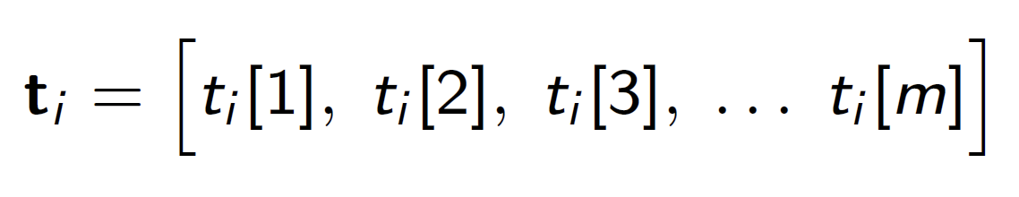
▶ Every trace ti contains m time samples i.e.
▶ Capturing n power traces with m time samples per trace results in the
measurement matrix M
▶ At some point in time the device should process the intermediate
v = y = S(p ⊕ k_{true} ) that we target
Input p
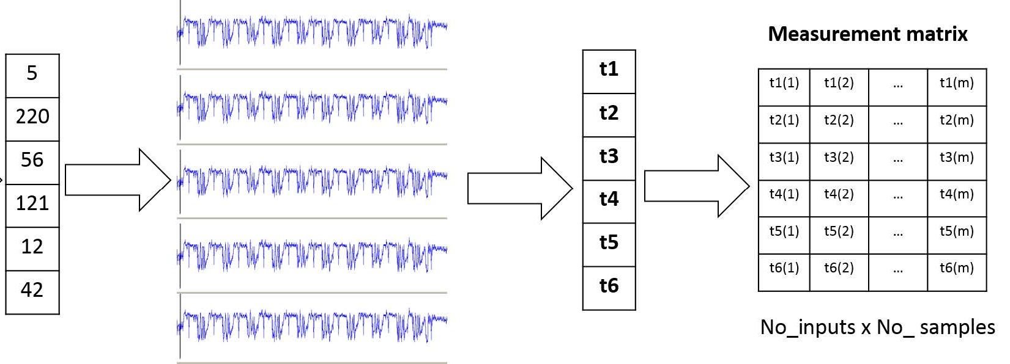
Step 3: Compute the hypothetical intermediate values
▶ In our device v = y = S(in ⊕ ktrue ), but k_{true} is unknown
▶ For any plaintext pi we can compute the value yi for all possible key candidates k ∈ {0, 1, . . . , 255}, only 1 key (1 col) correct
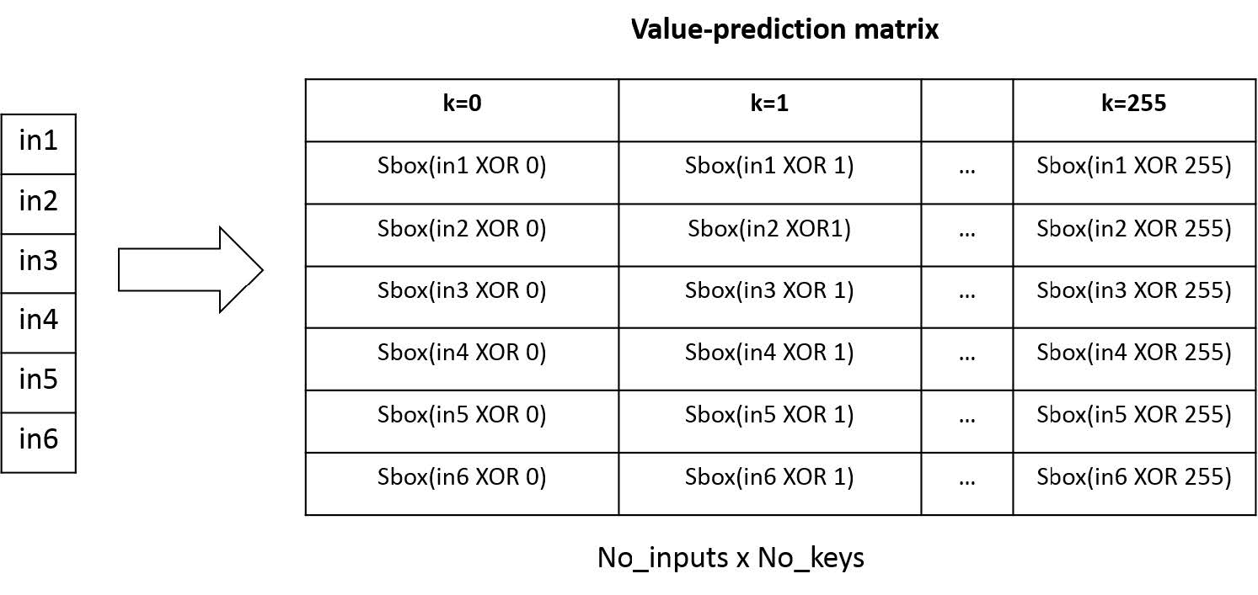
Step 4: Apply the leakage model
▶ We map the hypothetical intermediate values to hypothetical power
consumption values, producing the power-prediction matrix
▶ A common choice for leakage model is Hamming weight (HW) of a value
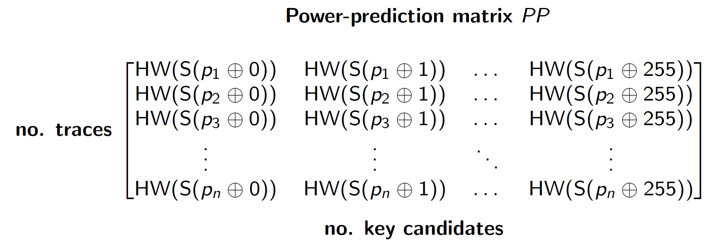
Step 5: Compare power-prediction matrix PP to measurement matrix M
▶ Use Pearson’s correlation coefficient: uncorrelated columns ρa,b ≈ 0, correlated columns ρa,b ≈ ±1, CPA use absolute correlation |ρa,b|
▶ Compare columns of power-prediction PP with measurement M
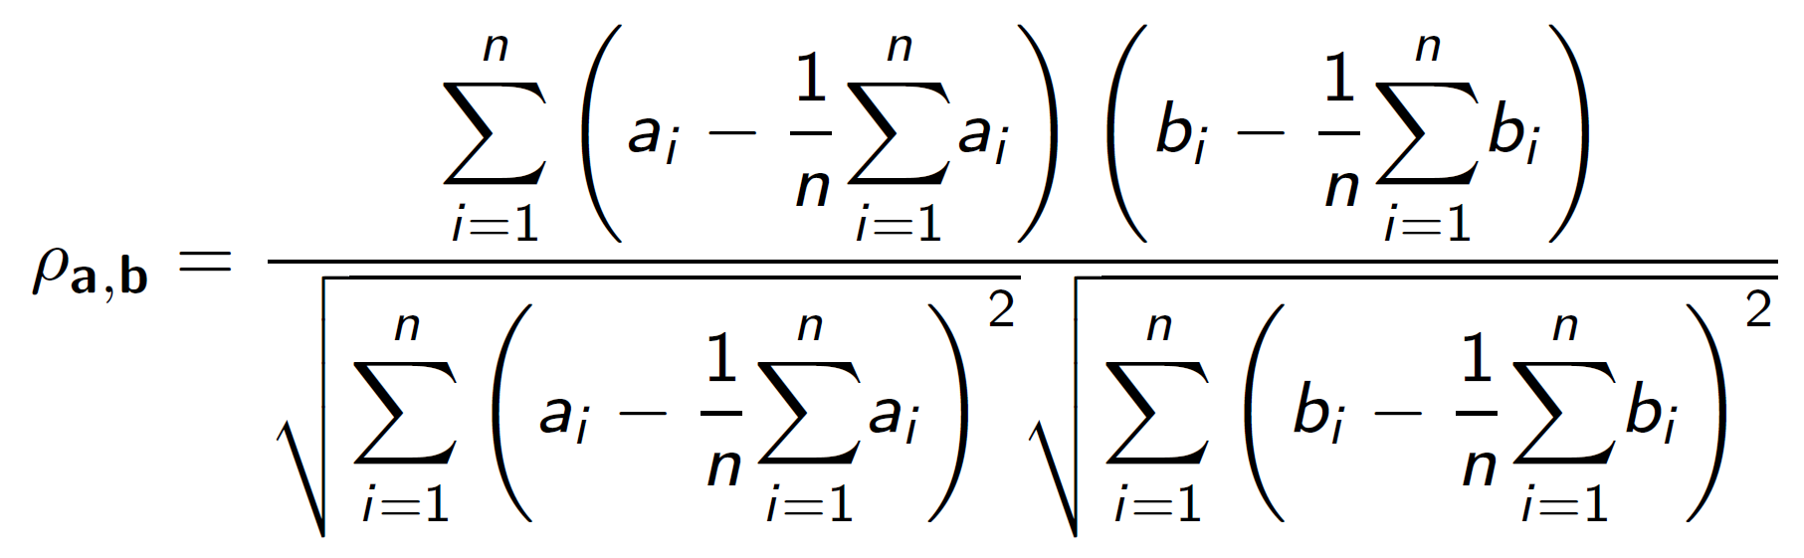
Hamming weight (HW) and Hamming distance (HD) models
- Hamming weight (HW) of value v: number of ‘1’ bits in v. Example: HW(10011)=3.
- HW often models bus precharge or software register loads (microcontrollers) where power correlates with number of ones.
- Hamming distance (HD) between two values a,b: number of bit flips to go from a to b (HD(a,b)=HW(a⊕b)). Example: HD(10011,01101)=4.
- HD models dynamic switching (register transitions) and is common for hardware (FPGA/ASIC).
- Use in attacks: Map hypothesized intermediate values to HW/HD predictions and correlate with measured traces (see CPA next).
Intrusion Detection Systems:
Confusion Matrix and Basic Metrics
- True Positive TP = P(‘alert’|‘intrusion’) = P(A|I )
- True Negative TN = P(‘no alert’|‘no intrusion’) = P(¬A|¬I )
- False Positive FP = P(‘alert’|‘no intrusion’) = P(A|¬I)
- False Negative FN = P(‘no alert’|‘intrusion’) = P(¬A|I )
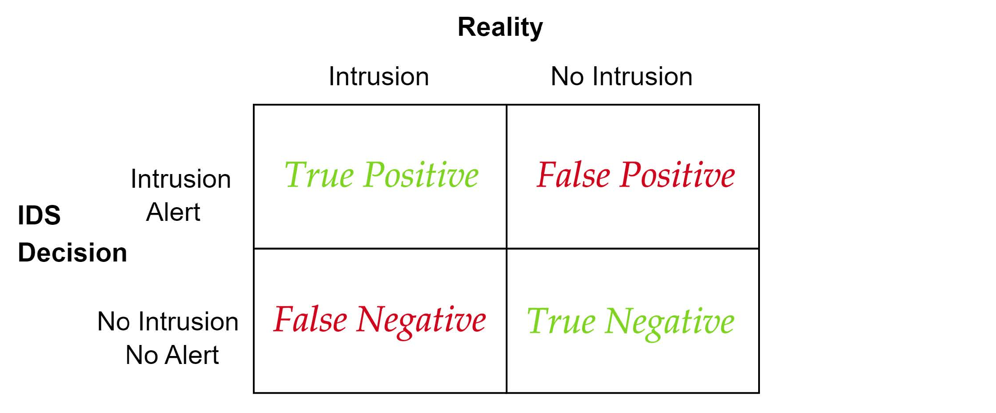
- Base rate parameter B = P(I) i.e. the probability of an intrusion
- Bayesian detection rate (positive predictive value) PPV
▶ PPV close to 1: after we see an alert, since an intrusion is likely
▶ PPV close to 0: can ignore the alert, since an intrusion is unlikely
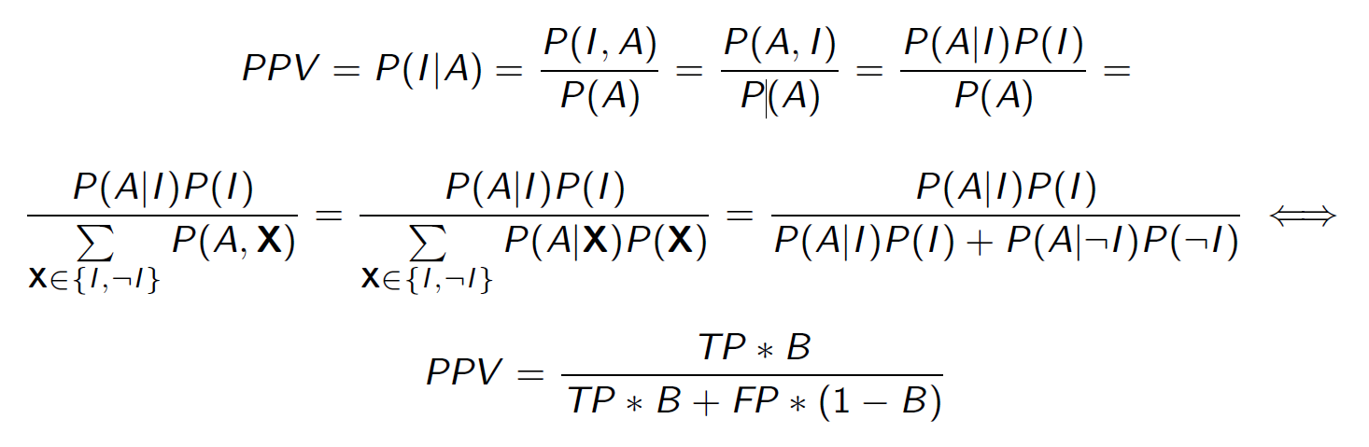
- Similarly, negative predictive value NPV = P(¬I |¬A)
Base Rate Fallacy (PPV can be low even with good TP)
- With rare intrusions (small B), even small FP dominates alerts.
- Example: TP=0.99, FP=0.01, B=0.001 → PPV ≈ (0.99·0.001)/(0.99·0.001 + 0.01·0.999) ≈ 0.09 (≈9% of alerts are real).
- Takeaway: Good IDS must good at suppressing false alerts, low FP
Decision Trees: Roll-Back (Expected-Cost) Analysis
- Leaves to Parent node, best operating point for IDS minimizes cost
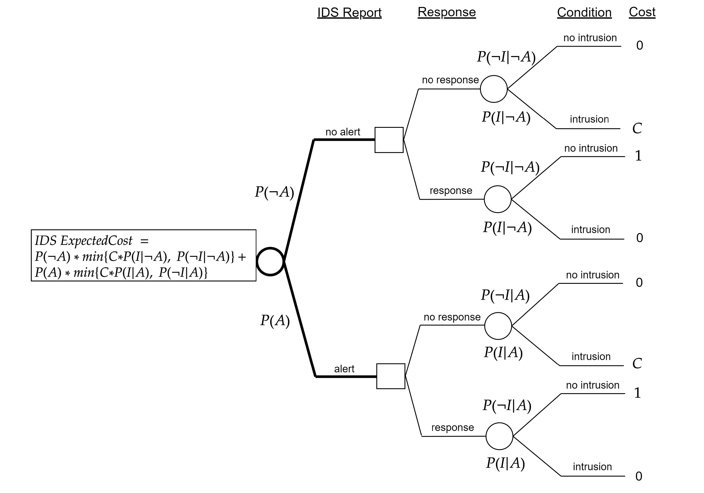
Receiver Operator Characteristic (ROC) Curve
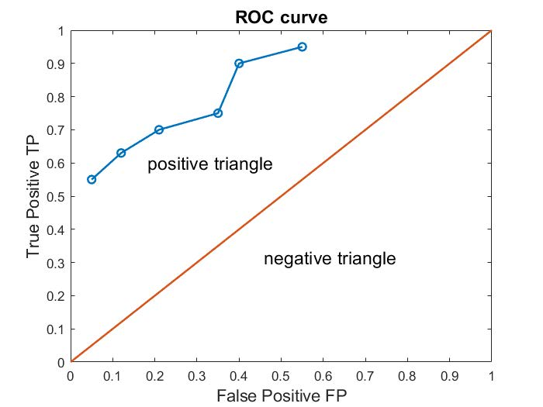
- 2d graph showing tradeoff between TP (y-axis) and FP (x-axis) in [0, 1]
- low TP / low FP ‘cautious’: will raise an alert if strong evidence
- high TP / high FP ’relaxed’: will raise an alert if weak evidence
- Goal is high TP low FP, above the line better than random guess
Distance Based Outliers (DBO)
- Definition: A datapoint o in D is a DB(p, d) outlier if at least fraction p of the datapoints in D lie in distance greater than d from o
- Construction
Step 1: Construct the following set S:
S = {x in D s.t. dist(o, x) <= d} dist(o, x) = Euclidean distance between o,x
Step 2: Compute the set cardinality |S|
If |S| <= (1 - p)|D| then the datapoint o is an outlier
If |S| > (1 - p)|D| then the datapoint o is normal behavior
- Simplify the anomaly detection problem and use distance metric
Isolation Tree (Isolation Forest)
- Construction
Assume that we have the following training dataset with:
▶ 6 datapoints stored in vectors {x0, x1, x2, x3, x4, x5}
▶ 5 features [x0, x1, x2, x3, x4] for each datapoint xi
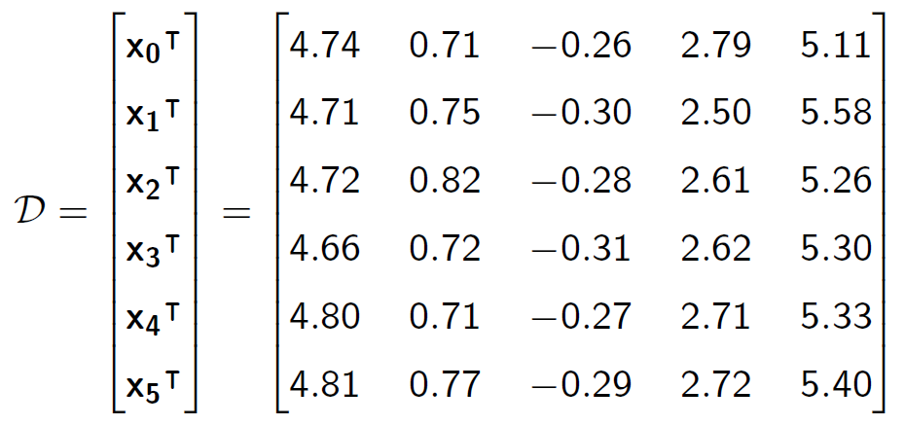
Step 1: Randomly select a feature q from {x0, x1, x2, x3, x4} e.g. q = x2
Step 2: Randomly select a split point p between max and min of q
e.g. max(x2) = -0.26 and min(x2) = -0.31 p = [-0.31,-0.26], pick p = -0.28
Step 3: Partition dataset D to the left and right sets D_{l} and D_{r} such that:
D_{l} = {x in D s.t. q < p} and D_{r} = {x in D s.t. q > p} refer as isolation tree (iTree)
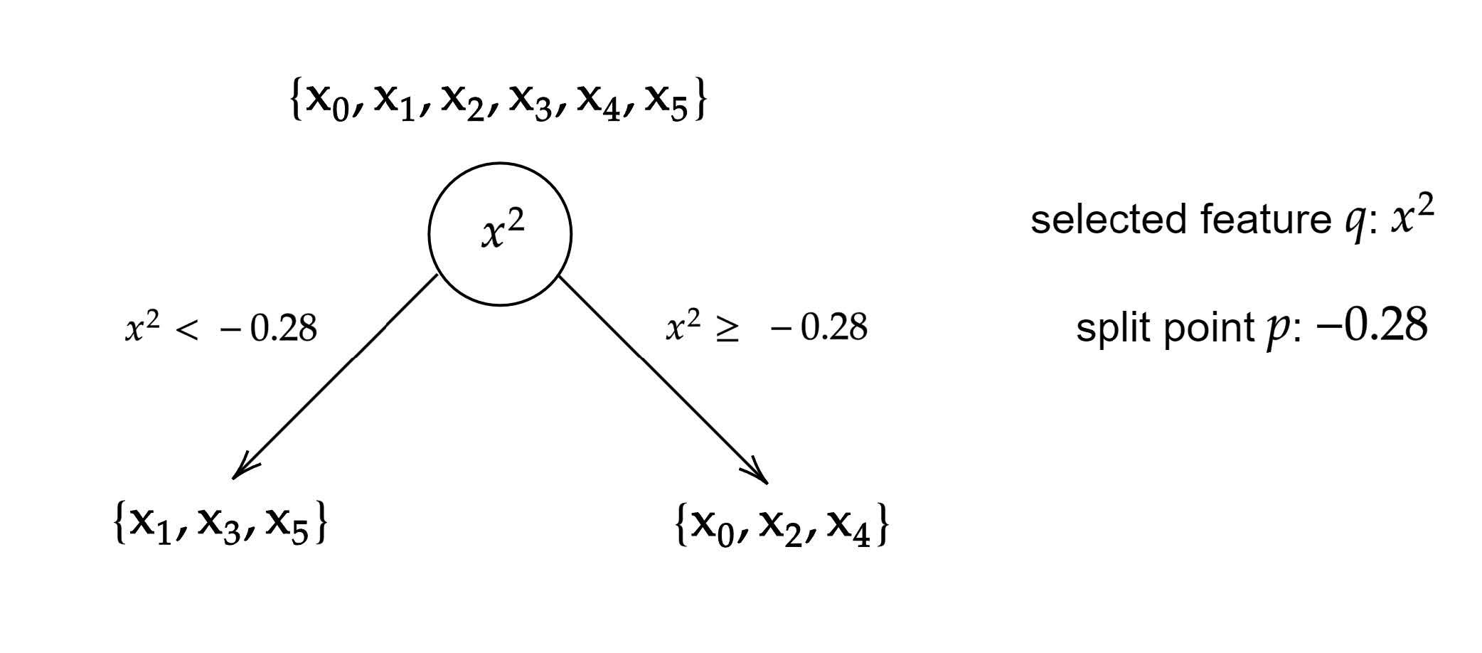
Step 4: The construction of the iTree continues recursively
- iForest idea: On average, the path length of anomalies is shorter compared to the path length of normal datapoints

RNG, IoT & OS security
Secure OS: Remove all the unnecessary software; Remove all the unnecessary services; Change default accounts ; Use the least privilege principle; Regularly update; Activate logging
Valid for IoT devices?
- Partly valid, but IoT is different: No antivirus; Limited support lifetime; Poor user interface; The programmers are not battle-hardened; The computer is connected to a physical device.
- Emphasize signed firmware, secure boot, automatic updates/rollback, strong device–hub/vendor auth, network isolation (separate VLAN), default-credential removal, and “hub as firewall/IDS” patterns.
Why IoT protection different from PCs/servers:
- Limited interfaces (no keyboard/screen) → weak configuration & visibility
- No/limited antivirus model and subscription economics
- Constrained resources → constant-time crypto and lightweight stacks; avoid heavy agents.
- Attached to physical processes → safety requires sanity checks (hardware interlocks).
- Cloud/vendor reliance → vendor compromise/abandonment risks; signed firmware a must.
- Usability economics → users rarely update; defaults persist; recovery/reset needs physical controls.
Pseudo Random Number Generator (PRNG)
- Definition: state ← F(state, seed) Generated from a seed; Sequences that have the statistical property of a random sequence
- Useful in security? A normal PRNG is deterministic and predictable once its seed or internal state is known → not safe for keys or nonces.
True random number generator
[ Entropy Source ] → [ Digitizer / Sampler ] → [ Post-Processing / Extractor ] → [ Ring Oscillators ] → [ Quantum ]

User authentication
Password entropy H(X)
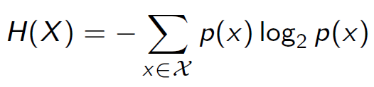
- Entropy is expressed in bits
- A higher number of bits implies more uncertainty
- When computing the entropy H(X) discard zero probability
- It holds that H(X) ≥ 0 always
Dictionary attacks and Salt values
- Verification: store (user, h), where h = hash(password). At login, compute h′ = hash(input) and compare h′ == h.
- Method: Let dictionary D that contains b most common passwords D = {x1, x2, . . . , xb} Attacker can hash them in advance, i.e. create a lookup table
H = {hash(x1), hash(x2), . . . , hash(xb)}
Attack amounts to a single table lookup in H thus it is much faster than computing hashes on-the-fly
- Salt value: a non-secret value for each password
Compute: h = hash(x||salt), Store in database: (userid, h, salt);
To verify a user password x’ Compute: h’ = hash(x’||salt), Compare: h == h’
Two-factor authentication (2FA): To login now I need something that I know + something that I have.
- e.g. a password together with a passcode generator / a password together with a hardware security token / a password together with mobile authenticator app / a PIN together with a smartcard

Privacy & Anonymity
K-anonymity
▶ Let a database D with non-sensitive attributes {A1,A2, . . . , An}
▶ Let a quasi-identifier Q = {Ai , . . . ,Aj} ⊂ {A1,A2, . . . , An}
▶ Let the database projection D[Q]
i.e. discard all attributes in D that are not in the Q set
k-Anonymity. We say that the database D satisfies k-anonymity with respect to quasi-identifier Q iff every sequence of values in the projection D[Q] appears with at least k occurrences
Benefits
- Ensuring k-anonymity prevents database linkage attacks with a bound of k
- Linking the datasets to external sources will not yield less than k individuals
l-Diversity
▶ Let a q∗-block in anonymized database D∗
▶ The block is l-diverse if it contains at least l well-represented values of the
sensitive attribute S
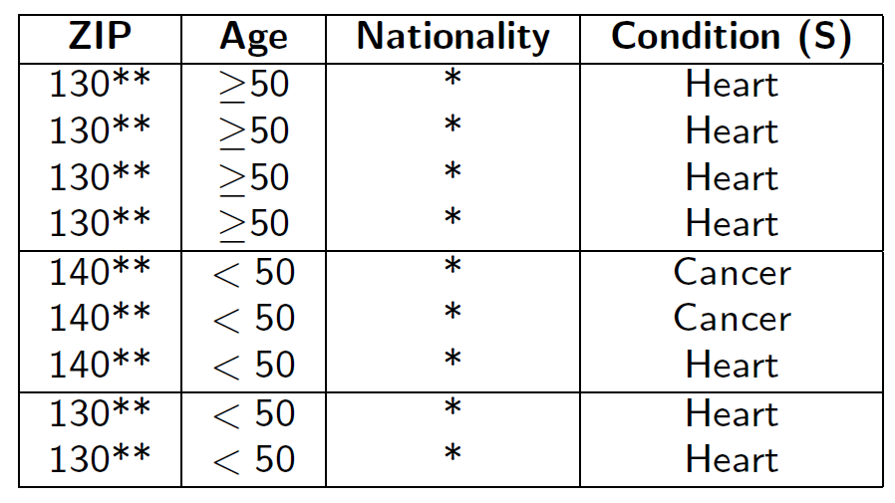
Example→
▶ Block 1, with q∗=[130**, >=50] has l-diversity of 1
▶ Block 2, with q∗ =[140**, <50] has l-diversity of 2
▶ Block 3, with q∗ =[130**, <50] has l-diversity of 1
Benefits
- Large values of diversity will ensure that the homogeneity and background knowledge attacks do not work
- Following the l-diversity principle you try to ensure: β(q,s,D∗) ≈ α(q,s)
Entropy l-diversity
A database is entropy l-diverse if for every q∗-block it holds that:
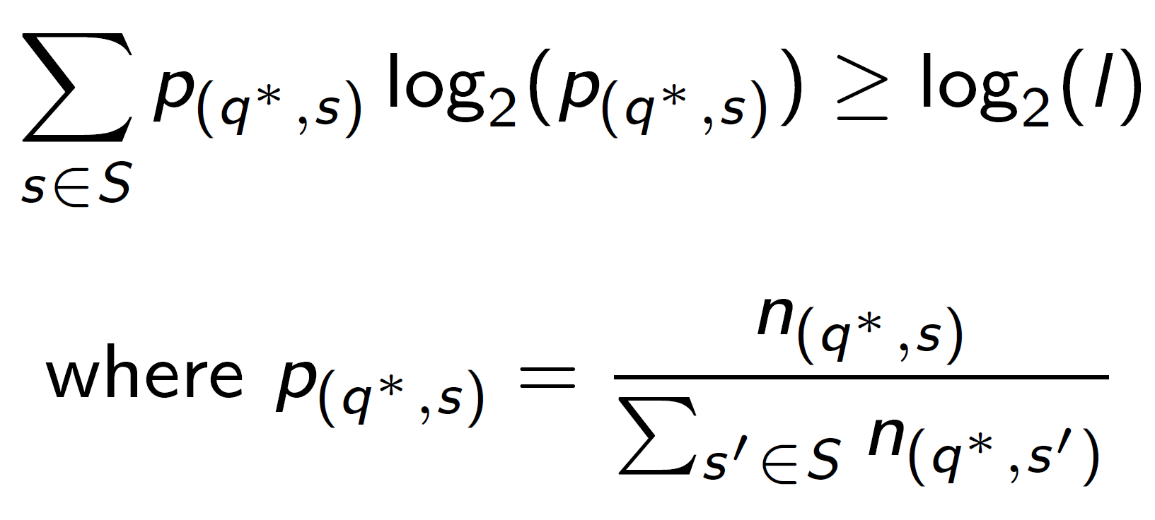
总数
单个

Security Protocols
MITM attack pattern (relay + substitution)
- Intercept A↔B handshake.
- Replace public keys/certificates or swap nonces.
- Replay previously observed signed values when freshness is not checked.
- If either party doesn’t validate a certificate chain or check that the key belongs to the claimed identity, attacker succeeds.
TLS Protocol: Handshake protocol (public-key operations)+ Record protocol (symmetric)
Handshake protocol
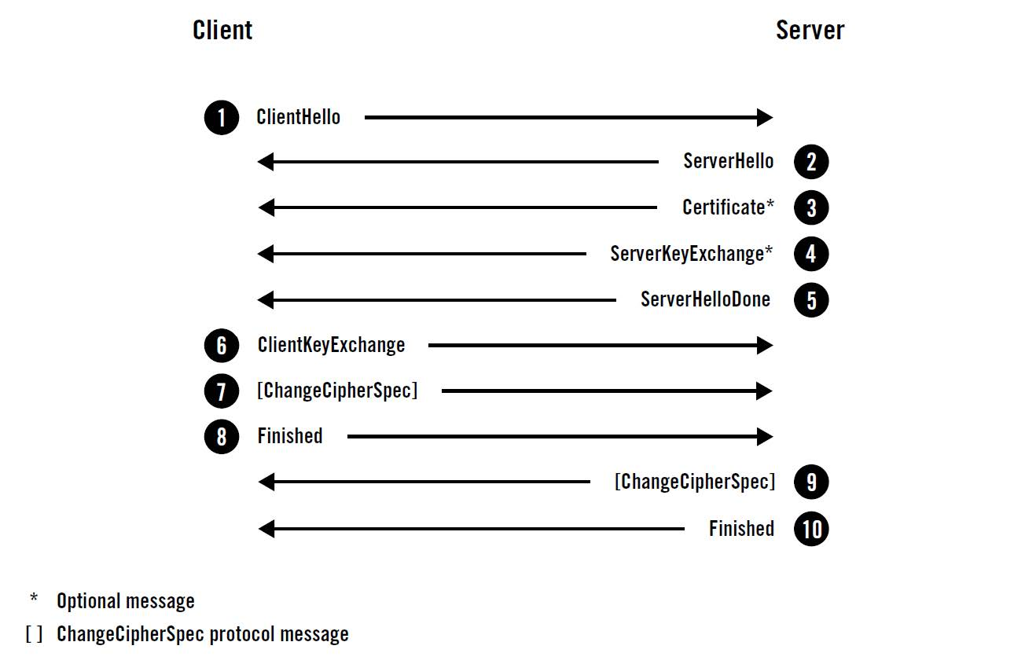
▶ A full handshake starts with ClientHello where the Client submits its connection and security parameters to the Server
▶ The Server replies with ServerHello that selected the parameters
▶ The Server sends a signed Certificate for authentication and the Client verifies the signature
▶ The Client and Server use public key cryptography to exchange keys. The Server sends the needed information via ServerKeyExchange and notifies that is done.
▶ The Client sends the needed information via ClientKeyExchange, derives the premaster secret and the master secret
▶ Now the Client switches encryption on and notifies the Server via ChangeCipherSpec
To verify the integrity of the hanshake so far, the Client computes a MAC(handshake messages) and sends it to the Server via Finished
▶ The Server derives the premaster secret and the master secret, switches encryption on and notifies the Client via ChangeCipherSpec
▶ To verify the integrity of the hanshake, the Server computes a MAC(handshake messages) and sends it to the Client via Finished
▶ A TLS session between Client-Server may now begin using a symmetric algorithm for bulk encryption of application data
Record Protocol
▶ Record protocol transports and encrypts all connection messages
▶ The record keeps also a unique 64-bit sequence number to avoid replays
